National Club Relays, Holme Pierpont Nottingham 25/08/2012

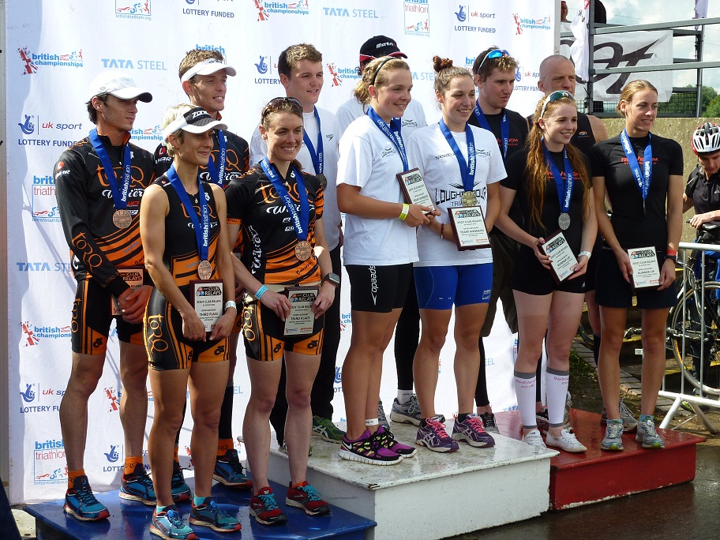
TORQ (Bronze), Loughborough (Gold), RedVenom (Silver)

TORQ’s super-team of Chris, Louise, Danielle and Ian were all really looking forward to racing the National Triathlon Club Relays, as it would be our first race together as a team. As individuals we’d been training towards a variety of events, from Elite Duathlons to Half-Ironman Championships. This would be an exciting chance to test our speedwork- and teamwork- against some of the best triathletes in the country.
Triathlon relays can best be described as ‘Organised Chaos’- with all 4 athletes completing a 500m swim, then a 15km bike, and finally a 5km run, passing a baton between them at every stage. TORQ would hopefully have an advantage in the baton-passing stakes, as our distinctive kit makes us easy to spot!
We voted for top swimmer Chris to get us off to the best start- which he duly did- battling through the kicks and punches to set us up well inside the top 10. Louise and Danielle then benefitted from some clear water (fewer kicks and punches!) to maintain a good position. The final baton change to Ian saw him dodging and weaving through a sea of athletes as he was now overtaking teams still on their 2nd and 3rd laps. So far so good!
A swift handover to Chris and it was onto the bike! Both Chris and Louise have been training for middle distance this year, so both benefitted from having put the bike miles in. The 5km laps positively flew by! In contrast this was Danielle’s first outing on her Wilier Twinfoil, having mainly raced draft legal this year. Despite a mechanical on the first lap, she still managed to fly round the course albeit more cautiously than she would have liked!
As our final rider, Ian had the luxury of an hour’s gap between swim and bike, and used this wisely to warm up his bike legs on the turbo trainer. Dedication that paid off with the team’s fastest bike split of 21:24. We had put ourselves at the sharp end of the race- round about the top 5 at this point. The podium was in our sights- but we knew we’d have to pull out all the stops on the run!
Luckily, as the commentator put it about an hour and ten minutes later- “TORQ certainly know what to do with a pair of trainers!” Chris laid down the benchmark with a flying 16:42 on the opening lap. The rest of us would have to run a little further, but all laid down impressive splits - TORQ was the only team to have all 4 athletes run sub-19 minutes for the 5km.
Louise managed to move the team up to 4th place, despite some very heavy and un-co-ordinated legs. Racing Ironman 70.3 in Germany 2 weeks ago had taken a bit of a toll! Danielle was also suffering from racing during the week. However for both girls- as the run is their strongest discipline, even a sub-par performance for them, is pretty rapid by anyone else’s standards.
Still in 4th place but closing in on the podium- it was all down to Ian! No pressure then! After a rapid baton change from the fast-finishing Danielle, he set off in pursuit of 3rd place. The rest of us could now only sit and wait...
First and second places were proving too far ahead to catch- with the Gold going to Loughborough University- the Junior Elites including Olympian Lucy Hall. Silver went to sponsored outfit RedVenom. And the bronze?...
Throughout the lap, the PA system kept announcing that Durham University were in 3rd place… but then all of a sudden- Ian appeared over the horizon and into the finishing straight! He had caught their runner with 2km to go, with the two of them battling it out until 250m to go, at which point Ian was able to put in a kick to leave the Durham athlete in his wake. He was then able to enjoy(!) the finishing straight without sprinting to the wire- as the rest of us cheered him on to the prize of a national medal. Go Team!!

